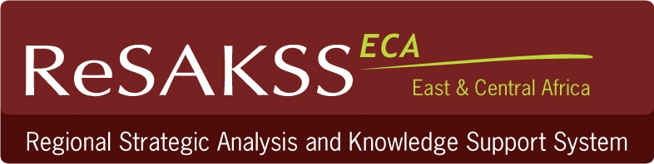




GIS Training Workshop on Agriculture Monitoring and Evaluation

ILRI, Nairobi 21th-26th February, 2011
Programme

Day | Session | Activity | Facilitators
Monday  Day 1  21th February,2011 | Morning  8.15am-13.00pm | Welcome remarks:  About ReSAKSS KM & M&E activities  Introduction to GIS concepts and data management in GIS | ILRI representative  ReSAKSS: Stella Massawe (SM)  SM & Patrick Kariuki (PK)
Monday  Day 1  21th February,2011 | Afternoon  2.00pm-5.00pm | Facilitated Practical exercises with examples  - Introduction to ArcView interface  Managing GIS data: managing projects and views, importing X,Y data into the view, setting view properties (scale,projections etc) Chapter 1 & 2 | Theuri Wachira(TW) & Stella Massawe
Tuesday  Day 2  22nd Feb,2011 | Morning  8.15am-13.00pm | GPS configuration, Capturing point data from surveys, GPS data download and related tasks | TW , AO and SM
Tuesday  Day 2  22nd Feb,2011 | Afternoon  2.00pm-5.00pm | Integrating field data into the GIS database and development of presentation maps | TW and AO
Wednesday  Day 3  23rd Feb,2011 | Morning  8.15am-13.00pm | GIS as a tool for Monitoring and Evaluation and Attributes manipulation in GIS  Cartography and use of Legends (Chapter 3 &8) | SM  SM, PK ,TW and AO
Wednesday  Day 3  23rd Feb,2011 | Afternoon  2.00pm-5.00pm | Manipulating tabular data in GIS –add and editing tables in GIS  (Chapter 4) | SM, PK, TW and AO
Thursday  Day 4  24th Feb,2011 | Morning  8.15am-13.00pm | Introduction to Geoprocessing  (Chapter 5)-followed by practical session | PK
Thursday  Day 4  24th Feb,2011 | Afternoon  2.00pm-5.00pm | Facilitated Practical exercises on basic analysis and Geo processing  (Chapter 6 and 7) | SM, PK, TW and AO
Friday  Day 5  25th Feb,2011 | Morning  8.15am-13.00pm | Facilitated Practical exercises in Geoprocessing  (Chapter 6 and 7) | PK
Friday  Day 5  25th Feb,2011 | Afternoon  2.00pm-5.00pm | Case studies and demonstration on various GIS products based on project data  Practical based on case studies | SM&PK
Saturday  Day 6  26th Feb,2001 | Morning  9.00am-10.30 am  11.00am-14.00pm | Finalizing exercise  Practical based on case studies  Group assignment using individual mapping tasks using own project questions plus Questions and Answers based on own project tasks  Group reporting back and discussions | Participants +facilitators  Participants+ facilitators
Saturday  Day 6  26th Feb,2001 | 14.00 | Lunch and Workshop evaluation

Breaks: Lunch and Refreshments/health breaks
Tea/ coffee and health break AM | 10.30-11.00am daily
Lunch | 13.00-14.00pm daily except Saturday where lunch will be at 14.00hrs
Tea/ coffee and health break PM | 15.30-16.00pm daily

